# Step 807 Valve State Verification

## Valve State Screenshot

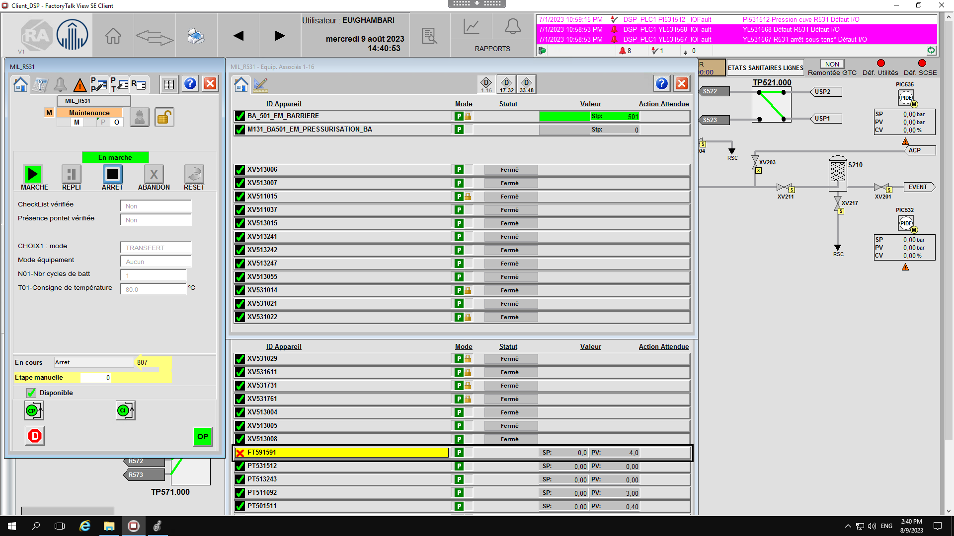

## Valve State Comparison Results

|  |  |  |  |
| --- | --- | --- | --- |
| Step 807 Results | | | |
| HMI / Live System Information | | Design Specification | |
| Valve Tag | Valve State | Valve Tag | Valve State |
| XV513006 | CLOSE | XV531029 | CLOSE |
| XV513007 | CLOSE |  |  |
| XV511015 | CLOSE | XV511015 | CLOSE |
| XV511037 | CLOSE |  |  |
| XV513015 | CLOSE |  |  |
| XV513241 | CLOSE |  |  |
| XV513242 | CLOSE |  |  |
| XV513247 | CLOSE |  |  |
| XV513055 | CLOSE |  |  |
| XV531014 | CLOSE | XV531014 | CLOSE |
| XV531021 | CLOSE |  |  |
| XV531022 | CLOSE | XV531022 | CLOSE |
| %V531029 | CLOSE |  |  |
| XV531611 | CLOSE | XV531611 | CLOSE |
| XV531731 | CLOSE | XV531731 | CLOSE |
| XV531761 | CLOSE | XV531761 | CLOSE |
| XV513004 | CLOSE |  |  |
| XV513005 | CLOSE |  |  |
| XV513008 | CLOSE |  |  |